Photo caption: Postcard. Credit: Jeff Jenson, http://home.comcast.net/~bygonebyways. This postcard image from the 1930s shows the Hug Point road when it was the only access to the outside world for the hamlet of Arch Cape. (Image from Jeff Jenson’s “Bygone Byways” Website)

Photo caption: Model T. Photo credit: OSU Archives, Gerald W. Williams collection
Cutline info: This image, made around 1915, shows a group with a motorcar traversing the Hug Point Road when it was the tiny settlement of Arch Cape’s only access to the outside world.

<title>Did this tiny, scary road save Oregon public beaches?</title>

<meta name="description" id="description" content="Blasted out of the rocky headland by a mysterious roadbuilder, the one-lane track made the beach the area’s only viable highway until the 1930s" />

<meta name="Keywords" id="Keywords" content="Hug Point, Oregon Coast, Cannon Beach, Arch Cape, stagecoach, Oswald West, public beaches, Beach bill, Highway 101, Oregon history, Governor West, Roosevelt highway, beach highway" />

Offbeat Oregon History

Tiny, soggy, scary road likely saved Oregon’s public beaches

Until Highway 101 was built in the 1930s, the beach was Arch Cape’s only road to the outside world — a fact that was Exhibit A in Governor Oswald West’s plan to save the beaches.

By Finn J.D. John — November 28, 2010

One of the strangest and most important roads in Oregon’s history is flooded almost every day. It has been since it was first built. Its origins are mysterious and for a good half-century the only traffic it’s seen is people on foot.

But a century ago, this roadbed was part of Exhibit A in Governor Oswald West’s bid to save Oregon beaches by declaring them state highways.

The road is a very short one-lane stretch cut and blasted into the rocky headland at Hug Point, just south of Cannon Beach. It’s actually just a small part of the road from Arch Cape to Cannon Beach – in fact, the road was the beach.

Drivers today do plenty of griping about the stretch of Highway 101 that covers that part of the coast. They don’t know how good they’ve had it since 101 was built in the late 1930s. Before that, travelers driving down the coast had to use the beach. And there was one particular spot everyone dreaded: Hug Point.

Hug Point got its name because travelers wanting to get from Cannon Beach south to Arch Cape had to wait for low tide and hug the point to get past it. It’s a steep, rugged ridge of the Coast Range that thrusts right out into the surf, to its very edge.

It was a regular feature on the stagecoach run up and down the beach. Into the sea the coach would plunge, and around the cape it would go. Nerve-wracking, yes, but any other way around the point would have involved a long inland detour, a big elevation gain and a whole lot of switchbacking and bushwacking.

Hug Point might have been an inconvenience for stagecoaches, but when automobiles started appearing it must have been a real problem. It takes a lot less water to stop a car than a stagecoach, and it’s much easier to get one stuck in beach sand.

So someone – I still haven’t been able to figure out for sure who, or when – someone blasted and chipped a roadbed out of the headland.

How did that road come to be? I’d love to know. Several sources claim it dates to 1920, when a man from Arch Cape bought a brand-new Maxwell motorcar and tried to drive it home. It got stuck in the surf while driving around the point, and the incoming tide submerged it. The man was so angry he raised subscriptions from his neighbors, bought dynamite and blasted out the roadbed – so the story goes.

The problem is, I have a photo of a horse-and-wagon team negotiating that roadbed that dates from 1910, and Ralph Friedman actually talked to a stagecoach driver who routinely drove the road well before 1920.

So who actually did the blasting and chipping? The Postal Service? The stagecoach line? Local residents? And when? Several hours of diligent scrounging through the catalogue at Oregon State University’s Valley Library have turned up absolutely nothing. Whoever did it clearly didn’t think it important enough to mention. If you know, I’d love to hear from you.

In any case, it worked. Stagecoaches, wagons and now automobiles could finally cross Hug Point at low tide without getting pickled in corrosive saltwater. And cross it they did, regularly; after all, there was no alternative.

Meanwhile, the Oregon public was getting increasingly agitated about the beaches. They were being sold off. The state legislature was diligently selling them at bargain prices to legislators’ friends and associates, and the spectre of “No Trespassing” signs in the sand loomed.

In response, voters elected Oswald West as governor. His platform was chiefly a promise to save the beaches. Once in office he knew what he had to do – but how could he do it?

Well, most Oregonians know how he did it – by getting the beaches declared state highways. But what most don’t realize is that West had to get that action approved by a hostile legislature that really wanted to keep playing Santa Claus with beachfront property.

The only reason he was able to do this is because he was right. In many places, the beaches really were highways, and there were no alternative routes.

That fact made all the difference. For 1910s legislators, it was one thing to vote to sell off a soft asset like a recreational area. Voting to unload a state highway on which voters depended for contact with the outside world was another matter.

So West got his bill. And we got our beaches. And, a little over 20 years later, the Arch Cape residents got a real highway – Highway 101 – and the Hug Point road fell into disuse.

Today it’s a state park, and at low tide beachgoers can stroll from one end to the other of the only remaining evidence of the road that saved Oregon’s public beaches.

(Sources: Friedman, Ralph. In Search of Western Oregon. Caldwell, Idaho: Caxton, 1978; Sullivan, William L. Hiking Oregon’s History. Eugene, Ore.: Navillus, 2006; www.ohs.org (Oregon Historical Society))

Finn J.D. John, an instructor at Oregon State University, writes about unusual and little-known aspects of Oregon history. He is currently working on a book about former Oregon resident Herbert Hoover during and after World War I, when he saved hundreds of millions from starving to death. To contact him or suggest a topic: finn@herberthoover.us or 541-357-2222.

Art thumbnails:

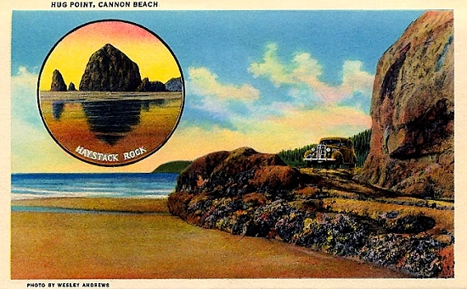

Cutline info: This postcard image from the 1930s shows the Hug Point road when it was the only access to the outside world for the hamlet of Arch Cape. (Image from Jeff Jenson’s “Bygone Byways” Website)

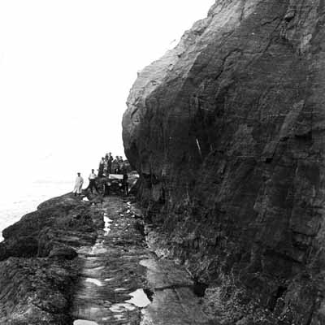

Photo credit: OSU Archives, Gerald W. Williams collection

Cutline info: This image, made around 1915, shows a group with a motorcar traversing the Hug Point Road when it was the tiny settlement of Arch Cape’s only access to the outside world.

Link to page comparing the old and new roads : Jeff Jenson’s «bygone byways » website…

http://home.comcast.net/~bygonebyways/Oregon_101.htm

Photo in Oregon IV :

http://books.google.com/books?id=YAXdVJ7SPVoC&lpg=PA41&dq=%22hug%20point%22%20oregon&pg=PA42#v=onepage&q=%22hug%20point%22%20oregon&f=false

1995 Blue Book page 96 : photo

OSU archives photo info :

Image TitleHug Point road at Cannon Beach, Ecola, Oregon Date.Original1915-00-00 SubjectRoads
Geographic SubjectsClatsop County (Ore.)
Hug Point (Ore.)
Object TypeImage Original FormPostcards
Original CollectionGerald W. Williams Collection
Collection seriesNorth Oregon Coast album
Item NumberWilliamsG:Hug_Point4 RestrictionsPermission to use must be obtained from the OSU Archives. Transmission DataMaster scanned with Epson 1640XL scanner at 800 dpi., 8 bit gray scale. Image manipulated with Adobe Elements 4.0. Contributing.InstitutionOregon State University Libraries Full resolutionVolume1\WilliamsG_Hug_Point4.tif

